Orientation to COTROnline /

Introduction
COTROnline is the College of the Rockies’ Learning Management System (LMS)​ used to conduct online courses, as well as support face-to-face teaching. ​It is built on the open-source platform called Moodle. ​
Moodle is designed to be a user-friendly platform that allows you to create and deliver personalized learning environments for your students.

Part 1 – Accessing your account and courses
To access COTROnline, enter cotronline.ca into any web browser.
To login, select the Log in button located at the top-right of the homepage.
Your username will be set to your first initial, followed by your last name. Your password is set to your network password, the same used to login to your college computer, as well as Portal and Web-Mail.
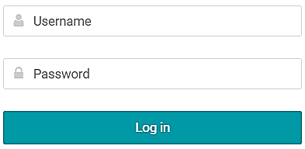
Your courses are made available from the My courses dropdown, and from the My Dashboard tab. You can view all of your past and present courses by double-clicking on My courses in the menu.
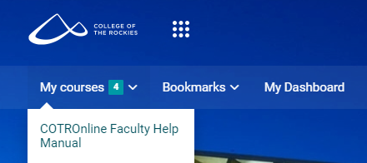

Part 2 – Editing your course

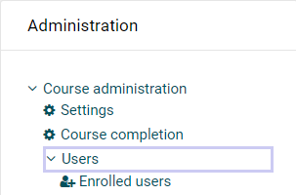
2-A – Course Users and Settings
To access the list of users for a course, select the Users dropdown from the Administration block, and then select Enrolled users.

To set the visibility of a course and control for other
general settings like start/end dates, select Settings from the same Administration block.
Note: Setting the dates of the course will adjust the pre-set weekly module dates, which default to a seven-day window beginning on the first day of your course.

2-B – Course Content, Activities and Resources
There are two viewing modes of the course content:
- Course Homepage View – this is the landing page of the course which displays all the modules for the semester and the content and activities they contain
- Activity Page View – this view begins once a student opens any activity or resource component. Students can complete whole modules while remaining in the Activity Page View and do not need to return to the Homepage view
Once inside a course, you can “turn editing on” by toggling the pencil-icon button in the top right corner to enable more options.
ON: 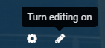 OFF: 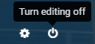
To add a new activity or resource, select the teal green “Add an activity or resource” button located at the bottom of every module week/section. *Be sure that Edit settings is turned on.
The different types of activities and resources within a course all have a unique icon, the majority of which are color coded by type:
Course content/resources – Blue
A full reference for the icons is available through the Faculty Help resource and via this link:
Legend for Moodle Icons.pdf (cotronline.ca)
Communication – Green
Collaboration – Orange
Assessment – Pink
Individual activities and resources can be edited by selecting the Edit dropdown – three vertical dots to the right of the activity – then selecting Edit settings. In the settings page, you can update the name of an activity, change due dates, configure grading options, etc.

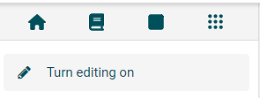
If you are viewing an activity from the Activity Page view, you can turn editing on and edit an activity’s settings using the following steps:
Select the other buttons icon in the top-left menu bar (nine dots). Select “Turn editing on”

Activity components that have completion requirements will display a variety of statuses down the left side of the Activities listed on the Course Homepage (or under the Activity name on smaller screens), these include (but are not limited to):
- To-Do: View – Will automatically be marked as ‘Done: View’ once opened by a user
- Mark as Done (button) – Students can manually set the status to Done by clicking on the button, it will not automatically change when viewed
- To-Do: Make a submission – Will automatically be marked as ‘Done: Make a submission’ once a student has successfully completed an assignment submission process.
- To-Do: Receive a grade – will automatically be marked as ‘Done: Receive a grade’ once the assignment has been evaluated and a grade released.

Part 3 – Resource tabs in Main Menu of COTROnline Homepage
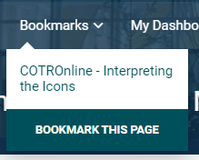
Aside from accessing course-pages via My Courses, COTROnline gives access to various help pages, and other resources for faculty and students. Below is a brief description of the different tabs available from the COTROnline homepage.
Bookmarks - Any page within COTROnline can be bookmarked for ease of access by selecting the “Bookmark this page” option from the drop-down while the page is live.
Note: to bookmark a course resource, you need to have editing ON.
My Dashboard - A full listing of past, present, and future courses will be displayed at the bottom of this page, under Course overview.
My Calendar - A full report of upcoming events and important dates.
My Media Galley - In this page you can add videos and images that can then be added to your course-pages or saved for later.

Student dropdown - This dropdown is a directory to various recourses for students, including a set of help pages for navigating COTROnline.
Faculty dropdown - This dropdown is a directory to various recourses for faculty, including a set of help pages for navigating COTROnline.
College Pages - This dropdown leads to other important sites related to the College of the Rockies, including AccessCOTR, LinkedIn Learning, Web-Mail, etc.
Messages - Opens a full chat window for messaging instructors and students.
Help – The help tab opens a guide for students. For any Instructor requests or need of assistance associated with COTROnline, you can reach the COTROnline help desk at: ​
Email COTROnline@cotr.bc.ca​ Office 104​
Microsoft Teams @COTROnline​ Local number 3737

